Foundations of Yoga
Test #2 Study Guide

1)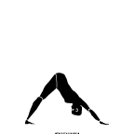 | 2)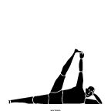 | 3)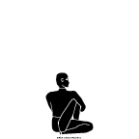
4)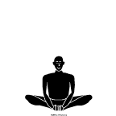 | 5)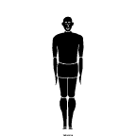 | 6)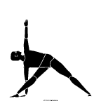
7)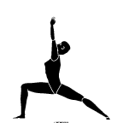 | 8)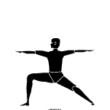 | 9)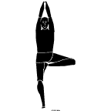
10)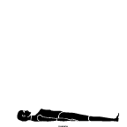 | 11)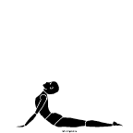 | 12)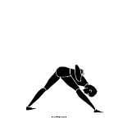
13)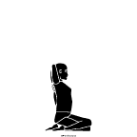 | 14)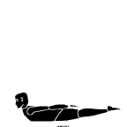 | 15)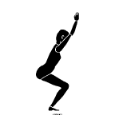

- Be able to name these 15 poses in English OR Sanskrit
- Give an example (from the above) of a backbend, forward bend, inversion and twist
- Which is the basic standing pose?
- Which is the basic supine (lying down) position used for relaxation?
- Pick any three poses and tell me what is being stretched.
- Does the old adage “no pain, no gain” apply in an asana practice? Why or why not?
(3 – 5 sentences)
- Describe Nadi Shodhanam Pranayama (alternate nostril breathing) and its benefits
(3 – 5 sentences)
- Describe Kapalabhati Pranayama (skull shining breath) and its benefits
(3 – 5 sentences)
- Why do we center before beginning our practice?
- What is meant by the term “counter pose”? What would be a good counter pose to navasana (boat pose)?
- How can we figure out if we are breathing diaphragmatically or not? If we find that we are not, how can we fix that?
- Why do you think it is important to do relaxation before you sit for meditation?
(3 – 5 sentences)
- If you are trying to meditate, but the mind keeps wandering, what do you do?
- Based on your dosha, which asanas did you find were most important for you to emphasize in practice? Why?
(3 – 5 sentences)
- Based on your reading of The Language of Healing by Dr. Timothy McCall, tell me what the difference is between Reductionism and Holism is in medicine? Which category do ayurveda and yoga fit into? And why?
(5 – 7 sentences)

